IP Routing

1.1 Brief Introduction

1.1.1 The Role of IP Layer
在TCP/IP协议体系中，IP层的主要任务是Forward Packet。 为了这个Task，需要做其他相关的事情，比如选择路由，分片。
我们常说的Router被称为三层交换机，因为它主要作用在TCP/IP协议体系的IP层。下面是一个示例：
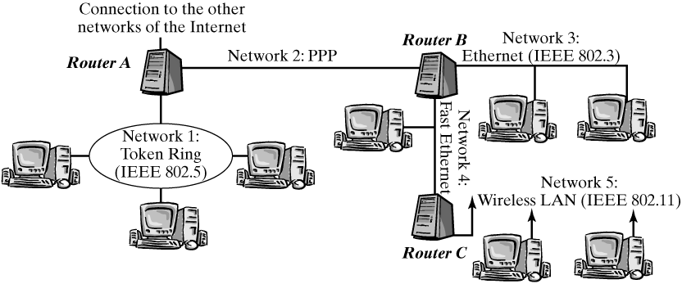
One of the most important functions of the IP layer (the network layer of the TCP/IP protocol architecture) is to forward packets between communicating end systems across a number of intermediate systems.上图中，Router A一端连接令牌环局域网(Network 1)，另一端是一个点对点网络(Network 2)，Router A为了使2个网络中的End system可以互相通信，它必须能同时识别PPP帧和802.5帧，且要做相应的转换，这些都是转发的步骤之一：
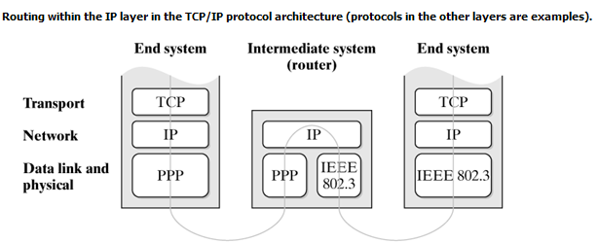
Points：
The network layer abstracts from lower layers, so it is irrelevant for the communication implemented over IP that the end systems are connected to different LAN types.
转发的大致过程：当收到帧后，首先根据帧类型skb->protocol, 调用相应的第三层Protocol Instance-Handler，或者ARP，或者RARP，或者IP，对IP Packet而言，它会调用ip_rcv()。ip_rcv()首先会查询路由，主要是得到转发给Packet的net_device，根据net_device的mtu，判断是否需要对该IP Packet分片，并根据目的网络的帧格式，封装该IP Packet，然后调用dev_queue_xmit()将该IP Packet发送出去。

1.1.2 Forwarding and Routing
Routers forward IP packets from one physical network to another, where the second network is normally "closer" to the destination network (not necessarily in the sense of geographic distance, but rather from a network-topology view) than the first network. To decide in what direction each packet has to be forwarded, the router requires a certain amount of information about the Internet topology, which it stores locally.
These methods to determine forwarding information in each router are also commonly called "routing.", 对于路由，我们2种不同的方式处理：
- Forwarding of IP packets in routers, which is based on given forwarding information. A router has to look up a database and make a decision for each packet that passes through this router on its way through the Internet.
- Routing: determining the best routes over which to transport each packet between networks, and deriving forwarding information from information about topologies and states exchanged regularly between routers within the entire network.
Forwarding is implemented in the Linux kernel, because it is a task of the IP layer. In contrast, routing is handled on higher layers: The routing protocols used to distribute information about network topologies and states normally build on top of transport-layer protocols, and the pertinent programs (routing daemons) are user-space processes running in Linux systems.
每个router或是end system都有route table，它就是关于路由的database。该route table的维护工作，包括add/delete/update，是由一个进程完成的：routing daemon，各个router/end system之间交换路由信息是通过应用层协议完成的，为了是路由信息达到全局最优而所遵循的准则被称为Route Protocol。而IP层的Packet转发只是查询这个route table以决定路由。本章只讲述如何查询该route table，以及该route table的结构。

1.1.3 Forwarding Procedure
For a router, an IP packet received over a network interface falls into one of three categories, depending on its destination address:
- The packet is addressed to the router: In this case, the packet is not forwarded, but passed to a protocol instance of the transport layer in the router.
- The packet is addressed to an end system in a neighboring network: Packets addressed to an end system in a network that is connected directly to the router over a network interface can be forwarded directly to this end system. When the packet is passed to the data-link layer, the physical address of the destination system, which might previously have been discovered by the ARP protocol, is used.
- The packet is addressed to an end system in a remote network: If the destination system is not in a neighboring network, then the packet has to be forwarded over an additional router. This router is identified from the forwarding information, and its physical address is used as destination towards the physical layer.
这三种情况都有相应的路由表与之对应。Case 1的路由信息放在local 表中，Case2和Case3的路由信息放在main表中。以下图为例：
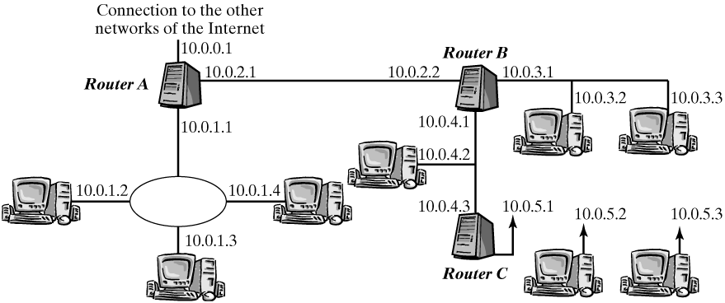
注：Each network interface in a router has its own IP address.
对于Router B来说，main表的内容如下(当然Linux实现中，具体内容比这要多得多)：
Destination | Network Mask | Router | Interface
10.0.3.0 | 255.255.255.0 | - | eth0
10.0.4.0 | 255.255.255.0 | - | eth1
10.0.5.0 | 255.255.255.0 | 10.0.4.3 | eth1
10.0.2.0 | 255.255.255.0 | - | ppp0
0.0.0.0 | 0.0.0.0 | 10.0.2.1 | ppp0
在查找一个route table时，总是先从网络前缀最长的开始，依次查找。通常网络前缀最长的为32，最短为0。如果找到了相应的entry，则查找停止。这也说明前缀长的entry比前缀短的entry的优先级高。
The most extreme example for this is an entry having its prefix length zero or its network mask 0.0.0.0. Such an entry represents all destination networks and is actually valid. It supplies a default route—the route packets should take when no specific entry exists for their destination address.，这种entry通常存在于end system的route table中，当然router的route table中也很常见。

1.1.4 Route Rule/Cache
① Rout Cache
In Linux, all routing-table entries are sorted by prefix length, and the table is searched successively by descending prefix length. This method is not always efficient, especially when the table includes many different prefixes. Rather than using different data structures to speed up the search process, Linux uses a routing cache to reduce the number of search processes. This cache stores the table entries used last and uses a hashing method that operates on the source address and destination address of packets to be forwarded, for accessing entries very fast. The routing table has to be consulted only for new address combinations not yet stored in the routing cache.

② Route Rule
An additional set of rules is then used to select which table should be used for what packets. This method is called rule-based routing or policy routing and allows you to include other criteria (e.g., the source address) in the routing decision, in addition to the destination address, whereas routing decisions taken from one single routing table are always based only on the destination address and the destination-network prefix specified in that one table.
一个rule中有一个rule table，每个rule都有一个优先级值。Each rule has a selector and a type. The selector chooses the packets to which the rule can be applied, and the type determines what should happen with a packet when the selector matches(selector根据Packet中的相关字段选择rule，type决定如何处理该Packet)。
The selector can contain the source address, the destination address, and the network interface at which the packet to be forwarded arrived，you also can use the TOS field or the iptables marking, which is called fwmark in the following discussion. 主要是将Rule中的selector和Packet中的相应字段对比，然后将符合的Packet应用于该Rule。
There are five types of rules: unicast, blackhole, unreachable, prohibit, and nat. The "normal case" is the unicast type: A specific routing table stated in the rule is searched for a route. The blackhole, unreachable, and prohibit types cause the packet to be discarded when the rule is applied. They differ only in the type of feedback to the sender: blackhole creates no feedback, unreachable reports that the destination network is unreachable, and prohibit reports that the communication is not permitted. The last rule type, nat, can be used for static network-address translation (NAT).
注：上述是应用的Rule时所代表的意义，当用在Route table entry中时，则表示另外的意义。
By default, the Linux kernel specifies three rules of the unicast type, with a selector each matching all packets. The priorities and identifiers for routing tables used for each type are defined as follows:
Rule Priority | Table Name | Table ID
0 | local | 255
32766 | main | 254
32767 | default | 253
local表中的entry数是固定的，通常只要IP地址不变，其内容也不会改变，它包含描述本地网络接口地址的条目。而main和default表的entry数不是固定，它可以根据全局的Route Protocol添加/删除/更新条目，主要是由Route daemon完成。The main table is intended for "normal" routing entries; the default table is suitable for lower-priority backup solutions.
Using just one procedure for all incoming packets, consult the set of rules and then the associated routing tables for each packet; if an entry is found in the local table, the packet is delivered locally—otherwise, it has to be forwarded.
因为是根据Priority的顺序来查询Rule的，所以先local表，再main表，最后是default表，如果rule-based routing被disabled的话，则只有local表和main表，这时查询则是先local，再main。

1.2 Implementation
本节首先介绍route table相关的数据结构，然后讲述ip_route_input()和ip_route_output()，它们被称为forwarding functions，在讲述这两个函数时会将所有关于路由的知识点串起来。

1.2.1 Routing Rules
每个Routing Rules都由一个fib_rule结构表示：
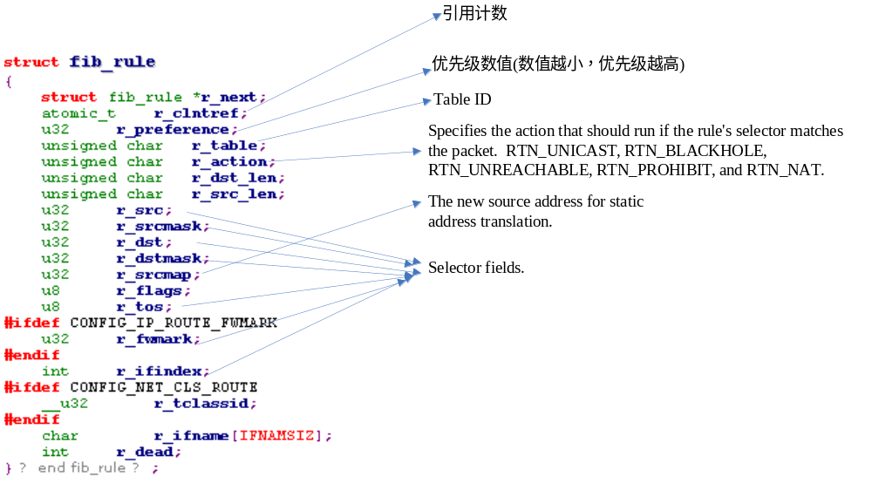r_ifindex, r_ifname就是收到Packet的网络接口的index和name。内核提供了RT Netlink Interface让用户可以添加/查询/删除Rule。
如果rule-based routing被disabled，则会有2个静态的Routing Rule，它们会匹配所有的Packet，且它们的action type是unicast：
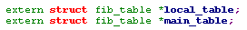
而且在调用fib_lookup时会首先查询local_table，然后再main_table:
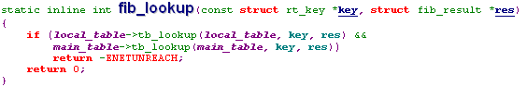
而如果rule-based routing是enabled，则内核会有3个Routing Rule，它们也都会匹配所有的Packet，且action type是unicast：
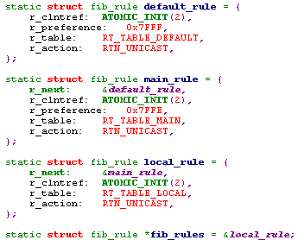
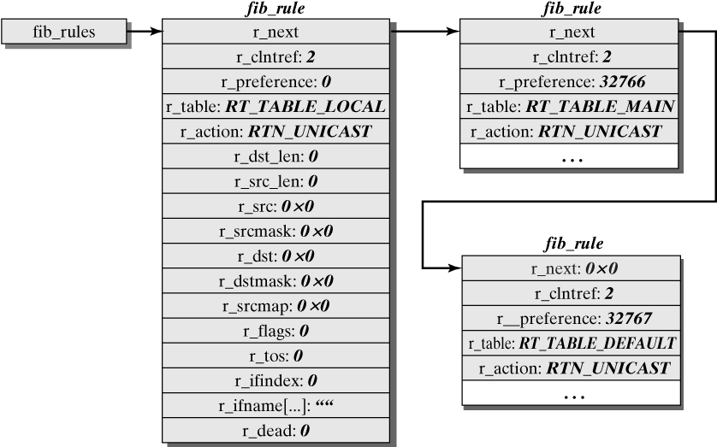
当要查询route database时，主要的调用接口是fib_lookup()：
它主要根据key的值来查询route database，并将查询结果放入res中返回。而key的类型是rt_key结构：
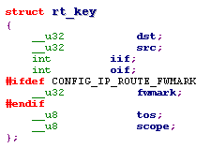
fib_lookup()的执行步骤是：The rules list is visited in the order of ascending priority value, and the action corresponding to the rule type runs for each rule with a selector that matches the key passed. Rules of the type unreachable, blackhole, and prohibit cause the function to be aborted and to return an appropriate error value. For unicast and nat rules, the routing table identified by the r_table entry of the rule is consulted，这时会查询该route table，通常会调用fn_hash_lookup()。If a table search is successful, then the result supplied by fn_hash_lookup() is returned; otherwise, fib_lookup() continues with the next rule，基本逻辑结构如下所示：
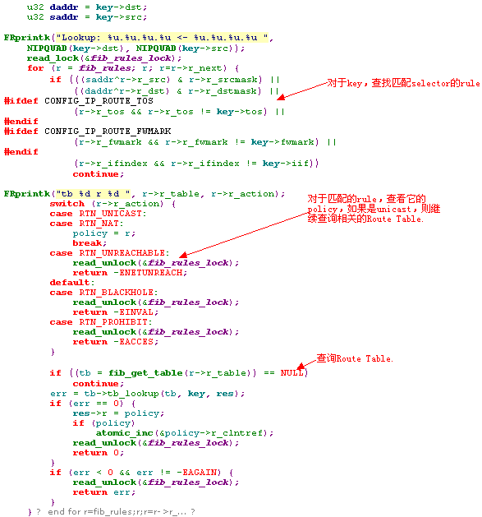
注：fib_select_default() select a route from several default routes; it is invoked whenever a previous FIB request returns a routing-table entry with a network prefix of length 0. It obtains the request key and the request result as parameters. The default route is actually selected by the function pointer tb_select_default(), which is included in the fib_table structure.

1.2.2 Routing Table
每个Route Table都对应一个fib_table结构。内核中最多可以存放255个Route Table，每个fib_rule结构中的r_table字段就是该数组的索引。
注：Only position 0 is not used; at the interfaces, identifier 0 denotes an unspecified table and normally is mapped to the main table.
fib_table结构主要由2部分组成：若干函数指针和fn_zone结构的指针数组。函数指针指向若干操作entry的函数(包括查询、插入、删除等)，而fn_zone结构的指针数组则构成了元素为fn_zone结构的hash表：
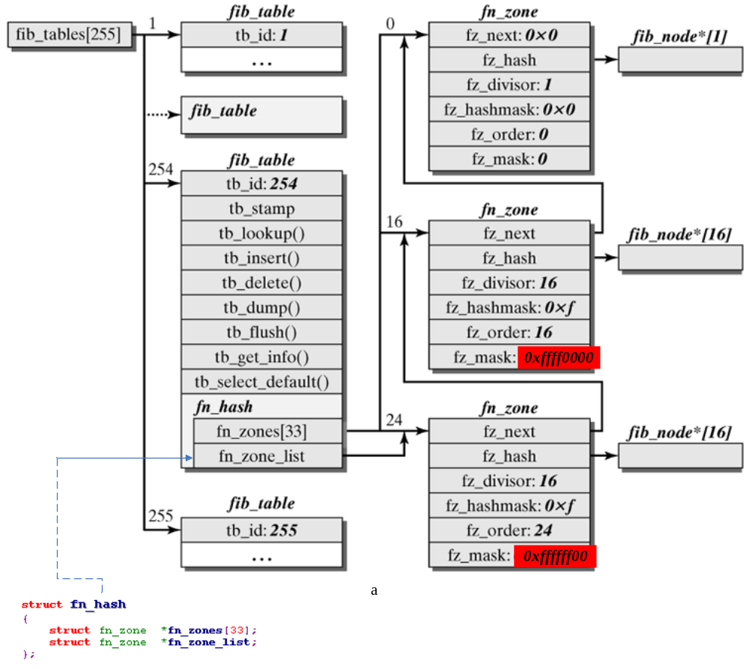
每个fn_zone中的entries的网络前缀长度都是一样的，这相当于根据网络前缀的长度给route table中的entries分类，如上所示，它给出了网络前缀长度为0/16/24的例子。fn_zone结构中包括fib_node的指针数组(数组长度为16)，其实它也是一个Hash表，根据网络前缀计算出index，得到一个fib_node的链表：
注：fn_zone_list永远指向网络前缀最长的那个fn_zone，这样在查找时，总是从fn_zone_list开始。
Each single entry in a routing table is represented by a fib_node structure. In its fn_key element, this structure contains the destination network prefix, and its fn_tos elements includes a TOS value, which is also part of the key used to search a routing table. The type and scope of an entry are coded in fn_type and fn_scope, and the fn_state element stores two flags used to manage the structure.
注：在表中查找entry的时候，主要将fn_key和fn_tos字段作为比较的字段。
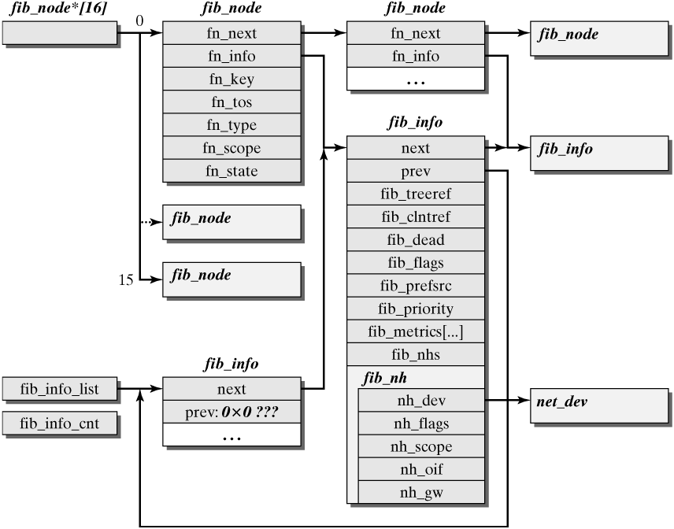
The fib_info structure represents information about the result of an FIB query, including the output interface to be used and the next hop along the route to the destination system, if necessary，其中最主要的信息是一个fib_nh数组，The fib_nh element is an array to represent the situation where several equivalent routes lead to the same destination in the FIB。这是因为可能去一个目标地址有多条路径。每条路径由一个fib_nh结构表示，其中最主要的字段是，nh_oif: Output interface to be used in the form of its index; nh_dev: pointer to the net_device structure for output interface; nh_gw: the IP address of the next router.
综上所述，路由的查询可以描述如下：为了要查询路由，首先给出关键字，包括源IP地址，目的IP地址、TOS、fwmark，r_ifindex(接收该包的interface索引)，首先查询匹配该Packet的Rule(查询字段：源IP地址，目的IP地址，TOS, fwmark, r_ifindex)，如果匹配的Rule类型是unicast，则查询它对应的route table，首先根据网络前缀的长度找到相应的fn_zone， 然后根据目的IP网络前缀和TOS找到相应的fn_node, 在fn_node结构里的fib_info结构里有一个fib_nh数组，如果数组元素只有一个，则返回该元素，如果有多个，则从中随机选择一个返回。返回的元素中包括output interface的相关信息和下一个router的IP地址。

1.2.3 The Routing Cache
Each forwarding operation first consults the routing cache, and the FIB is queried only if no matching entry exists in the cache. The result of the FIB query is then used to create a new cache entry immediately.
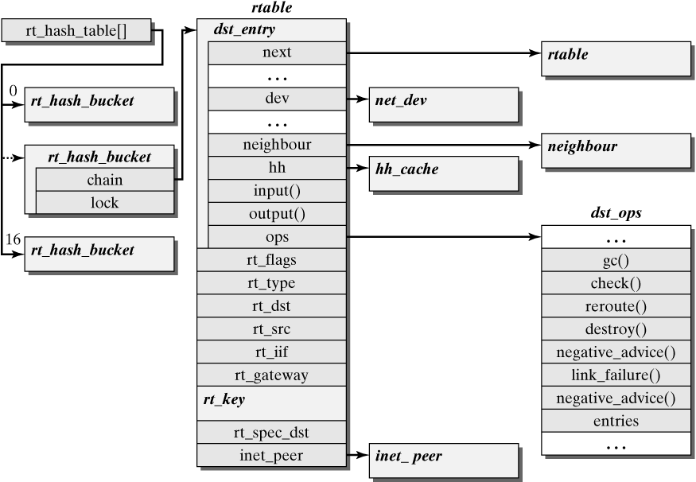
这里是一个Hash表，由全局变量rt_hash_table指示。首先根据Packet的目的IP地址、源IP地址 iif和TOS得到相应的rt_hash_bucket结构，其中chain字段指向的rtable结构就是cache entry了:
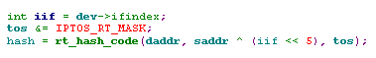
每个cache entry对应一个rtable结构，如果发生Hash冲突，则相同的hash值的rtable结构链入同一个rt_hash_bucket中。
每个cache entry对应一个rtable结构，下面简单介绍一下该结构的字段：
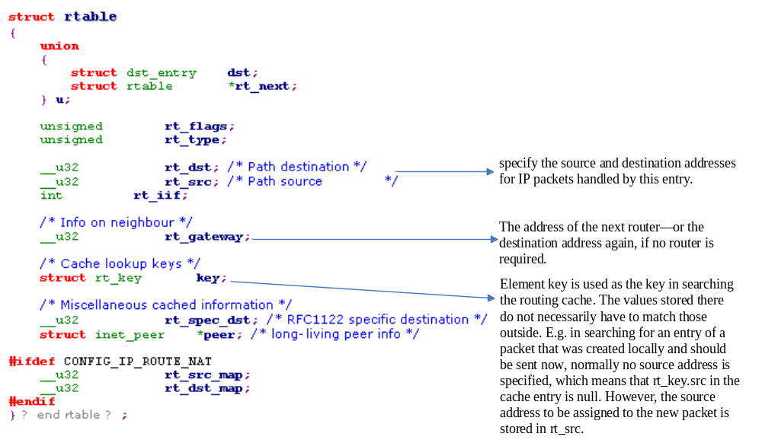另外，dst_entry结构也是cache entry的主要信息，它的主要结构如下：
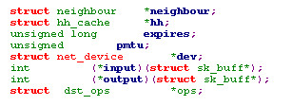
- The net_device structure of the output interface, the neighbour structure to the next router or the destination system (corresponding to the rt_gateway element in the rtable structure), and the hh_cache structure, which includes a packet header of the data-link layer that just has to be copied.
- Function pointers to operations for further processing when receiving (input()) or sending (output()) an IP packet that matches the cache entry are simply invoked at the appropriate positions within the IP protocol procedure, to result in the packet's being handled appropriately. The input() pointer in entries that can be used for incoming packets refers to ip_local_deliver() (unicast packets to be delivered locally), to ip_mr_input() (multicast packets), to ip_forward() (packets to be forwarded), or to ip_error() (forwarding impossible because destination is unreachable). The output() pointer refers to ip_output() (unicast packets) or ip_mc_output() (multicast packets).
- pmtu是output interface中最大帧大小。
Cache Garbage Collection
An entry is added to the routing cache for each new communication partner in the Internet, so we have to ensure that old entries that are no longer needed are deleted occasionally to limit the memory requirement and to keep cache searches fast in the long run.
First, a timer called rt_periodic_timer, which is initially started by add_timer() in the initialization function ip_rt_init(), invokes the function rt_check_expire() at regular intervals. This timer is restarted in rt_check_expire(), where the interval (measured in 1/HZ seconds) is specified by the global configuration variable ip_rt_gc_interval.
Second, whenever the number of entries in the cache exceeds a threshold value, the function rt_garbage_collect() is invoked to delete old entries also. A call to rt_garbage_collect() is also made when an attempt to allocate a neighbour structure has failed. This is done because it is then assumed that the corresponding tables are full, because some neighbour entries are referenced by routing cache entries and therefore they cannot be deleted. Old routing cache entries are deleted to remedy this problem.

1.2.4 The Forwarding Process
这里主要说明2个函数，ip_route_input()和ip_route_output()，它们是查询route database的entry point。
1) ip_route_input()
The function ip_route_input() is invoked for each IP packet arriving over a network interface. The parameters are a pointer to the socket-buffer structure, the destination and source addresses, the TOS value, and a pointer to the net_device structure of the receiving network interface.
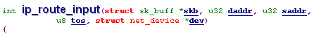
- First, rt_hash_code() is invoked on the source&destination IP addresses and the TOS value to compute an index in the hash table of the routing cache. If necessary, the list anchored in the chain element is walked through to find a cache entry matching source&destination IP addresses, input interface index, TOS value, and fwmark, if present. If this search is successful, then a pointer to the entry is placed as dst in the sk_buff structure, and the task is complete:
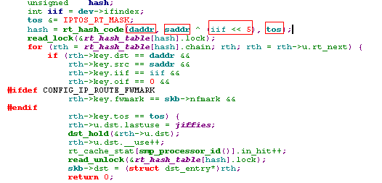
- If no matching cache entry is found, then either of the two following functions is responsible for further handling:
      - ip_route_input_mc() is invoked if the destination address is a multicast address. Another prerequisite is that the input interface either belongs to that multicast group or has been configured for multicast routing. The packet can be discarded if this is not the case. The function ip_route_input_mc() will be introduced in next chapter.What is done there is similar to the procedure for local-destination addresses described below, the only difference being that the packet is always delivered to the local machine rather than causing an FIB query.
      - ip_route_input_slow() is invoked to serves to handle "normal" destination addresses. 其实这里ip_route_input_slow()是做一次FIB query，如果query成功，将结果插入到route cache中。
下面主要介绍ip_route_input_slow()的执行过程。
2) ip_route_input()------>ip_route_input_slow()
- 首先是根据传入的参数创建一个rt_key结构：
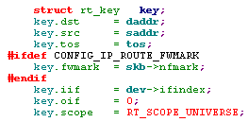
- 检查源IP地址和目的IP地址：
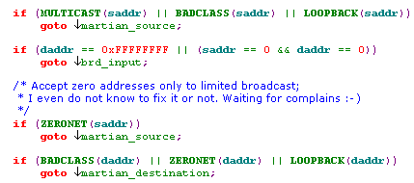
从代码中看，源IP地址不能是多播地址或环回地址(127.x.x.x)或网络前缀为0，而目的IP地址不能是环回地址或网络前缀为0，不然直接drop该Packet。而对于目的地址为0xFFFFFFFF或源/目的IP地址均为0时，this is occasionally used for automatic network configuration。这时不执行FIB query，它会将res.type 设置为RTN_BROADCAST，且将input置为ip_local_deliver，output置为ip_rt_bug。受限的广播地址永远不转发。
- Next, the FIB query is started by calling fib_lookup(). If no matching entry is found, then ip_route_input_slow() also aborts processing and returns an error code, which subsequently causes ip_rcv_finish() (from where ip_route_input_slow() was invoked) to discard the packet. 实际上，当没有matching entry时，它会将一项结果插入route cache中，其中主要是将input指针设置为了ip_error，它只是发送ICMP Message以及返回error。
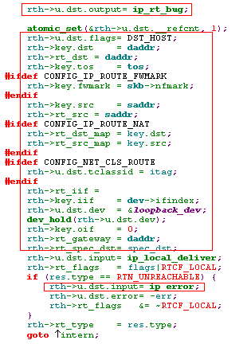

- If the routing NAT is active, the next step transforms the source address according to the information in the routing rule used (or the destination address, if the route found is a NAT route). Once the destination address has been transformed, fib_lookup() has to be invoked once more to find a regular routing entry (no other transformations are permitted) to the new destination address。
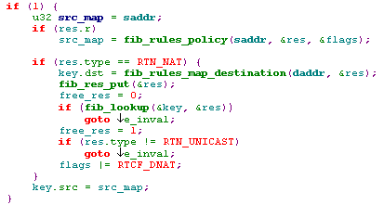
注：NAT转换后的源IP地址和目的IP地址都存放在route cache的rtable结构里：
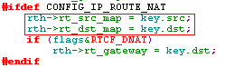
- The result from the FIB query also shows whether the destination address is a local address, which means that the packet is intended for the local system. This case is handled separately in the further process.
- Local destination address: A new cache entry is created once the source address has been checked by the calling of fib_validate_source(). The function pointer output() is set to ip_rt_bug(), because the packet is not allowed to leave the system. Next, the input() pointer is set to ip_local_deliver(), to cause the packet to be delivered to the local machine. Because there is no next router, the rt_gateway element of the cache entry is set to the destination address.
- Broadcast addresses, such as the 0.0.0.0 address mentioned above as source and destination or the normally limited broadcast to 255.255.255.255 are detected in the address validation at the beginning and handled identically to local destination addresses. However, fib_validate_source() is not called for 0.0.0.0 addresses. (查询的结果是RTN_BROADCAST，input()置为ip_local_deliver，而不再转发, output置为ip_rt_bug)
- Nonlocal destination address: Nonlocal destination addresses have to be handled only if the forwarding function for the input interface is enabled, so this is checked first.(这时会将input()置为ip_forward, output置为ip_rt_bug())
注：rtable结构中的rt_key字段里的oif始终为0。
- 最后调用rt_intern_hash()将查询到的entry插入到route cache中，并根据rt_gateway的IP地址将相应的neighbour 结构设置到rtable中。

3) ip_route_output()
当要发送本地创建的Packet时，也会需要根据目的地址选择路由，这时会调用ip_route_output().比如IP协议实例调用ip_queue_xmit()or 或UDP协议实例调用 udp_sendmsg()时。
- 首先是根据传入的参数创建一个rt_key结构，其中oif是sock中设置的bound_dev_if字段，它的作用是绑定一个net_device到一个sock，使得无论该sock发出的packet都路由到该net_device，参见附录Socket绑定机制:
- 调用ip_route_output_key().
4) ip_route_output()------>ip_route_output_key()
The routing cache is searched for a matching entry, and the process branches to ip_route_output_slow() only if no such entry is found. Rather than the input interface, the output interface is used for hash computation and comparisons：
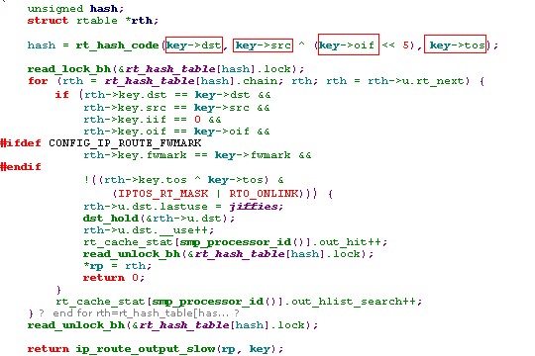
4) ip_route_output_key()------> ip_route_output_slow()
ip_route_output_slow() is invoked if no entry for the destination of a locally created IP packet exists in the routing cache. This function runs an FIB query, enters the result in the routing cache, and returns the new entry.
- 创建一个新的rt_key结构，根据参数中的的内容给它赋值：
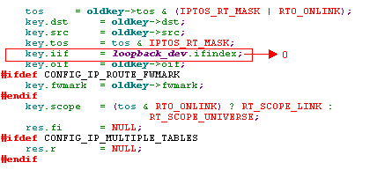
注：The loopback device is always assumed for iif
- 根据参数中的源IP地址和oif，对参数进行检查：
For multicast destination addresses, a route is created immediately without FIB query if a valid source address is specified, which can be used to identify a usable output device; For a specified output interface, a matching source address is found, and 127.0.0.1 is used for the destination address, if none is specified.
① 如果设定了源IP地址，则检查该源IP地址是否为多播地址/无效地址/网络前缀为0，如果是则返回错误。接着查看该源IP地址对应的net_device，如果找不到该net_device, 则返回错误。最后，如果oif为0，而且目的IP地址是多播地址或为0xFFFFFFFF, 则创建一个路由而不去进行FIB Query。这时如果是广播地址(0xFFFFFFFF)，则input设置为ip_local_deliver， output设置为ip_mc_output， 如果是多播地址，input设置为ip_mc_input， output设置为ip_mc_output。它们的rt_gateway设置为目的IP地址。
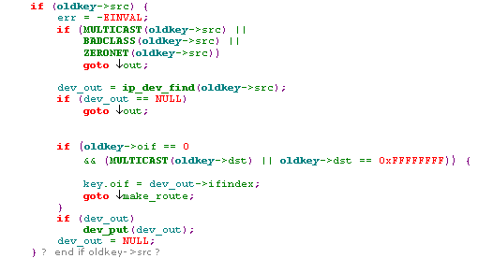
      - 如果没有指定目的IP地址（为0），则将其认为是127.0.0.1，如果它的源IP地址也是0，则将其源IP地址也认为是127.0.0.1且output interface指定为loopback_dev，不调用FIB query而直接形成Route，这时它的input为ip_local_deliver，output为ip_output,，这时key->src为127.0.0.1， key->dst也为127.0.0.1，rt_gateway也为127.0.0.1，即IP Header中的源地址和目的地址都是127.0.0.1.
注：当该Packet通过loopback_dev设备发送出去的时候，loopback_dev只是将它链入input queue中，然后触发软中断NET_RX_SOFTIRQ，然后会调用ip_rcv(),因为该Packet的路由信息已经存在，所以不会再调用ip_route_input()了，而是直接进入上一层进一步处理。
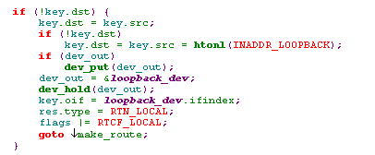
注意：loopback_dev是一个net_device结构，它代表的是环回接口，它的函数指针如下：
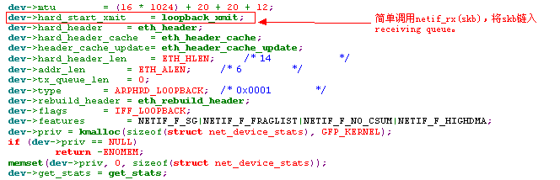
- An FIB query is started once all preparations have been completed. Notice that the process can, in some cases, continue even if this query returns a negative result. In fact, if an output interface was specified during the call, then this interface is used by simply assuming that the destination is in the adjacent network.
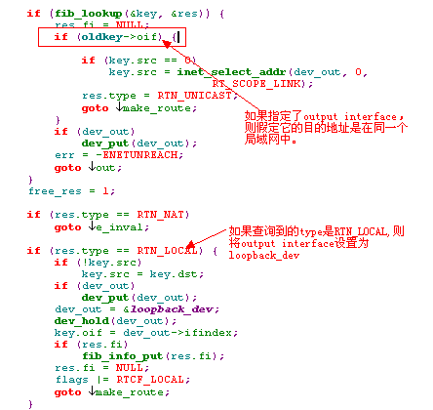
- 根据fib_lookup的结果生成对应的route，如果type是RTN_LOCAL, 则它的input为ip_local_deliver，output为ip_output; 如果type是RTN_BRODCAST，则它的input为ip_local_deliver，output为ip_mc_output；如果type是RTN_MULTICAST，则它的input为ip_mr_input，output为ip_mc_output。
注意：对于RTN_ MULTICAST或RTN_BRODCAST，ip_mc_output会首先把该Packet复制一份，send给Local，然后再把它发送出去 (帧头的MAC目的地址是0xFFFFFFFF或是MAC组播地址)
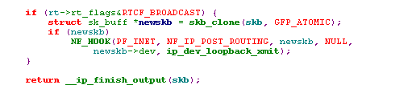
- 如果查询结果的网络前缀为0，且它的type是RTN_UNICAST，则调用fib_select_default()去选择一条default route，它只是在prefix length为0的fn_zone中的fib_node链表中选择一个entry。
- 最后调用rt_intern_hash()将查询到的entry插入到route cache中，并根据rt_gateway的IP地址将相应的neighbour 结构设置到rtable中。

补充资料：
- 每个路由表中的entry比较的都是网络前缀。也就是说，先将目的地址与Mask执行’&’运算得到网络前缀，然后根据这个网络前缀到route table中查找。
- NAT会改变IP Header的源IP地址和目的IP地址，通常在ip_forward()中调用ip_do_nat(), 该函数改变IP Header。相应的Route Entry中的rt_src, rt_dst分别为原始的IP源/目的地址，而rt_src_map, rt_dst_map对应的mapping的源/目的地址，在查询route table时，还是会以原始的地址为key，而output interface是以mapping的目的地址所查询的结果。
3) 发送Packet都是通过socket完成的，通常情况下，sk->saddr为0，当通过query到相应的路由后，根据dev_out的IP地址设置该Packet的IP Header的源地址：
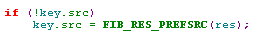
4) 发送Packet都是通过socket完成的，sk->saddr通常为0，sk-> bound_dev_if可能不为0，当为该socket发送packet时，选择路由后，并不会修改sk里的任何值(sk->saddr, sk->daddr，sk->bound_dev_if)，而且route table cache中key的值还是以sk->saddr, sk->daddr，sk->bound_dev_if为主。 只是可能修改IP Header中的信息(源IP地址或目的IP地址： NAT，Source Route Option)。

1.3 Summarize
1) 初始化：
每当初始化一个net_device时，总是会调用fib_add_ifaddr()对route table进行初始化。具体来说，它会将该net_device的IP地址，广播地址以及本局域网的网络地址添加到route table中：
以我的机器为例，它只有一个物理网络适配器，它的IP地址为10.111.3.161, mask为255.255.248.0，也就是说它的Prefixlen为21。
除了物理的适配器外，loopback_dev也一样，它的IP地址为127.0.0.1，prefixlen为8，即它的mask为255.0.0.0。
将所有net_device初始化完成后，其route table如下所示：
表名： local
目的地址的prefix | fib_zone的字段 |  | fib_info的字段
目的地址的prefix | fz_order | fz_mask | nh_gw | nh_dev | nh_oif
10.111.3.161  （RTN_LOCAL） | 32 | 255.255.255.255 | 0 | 指向该物理适配器对应的net_device结构 | 该物理适配器对应的net_device结构
10.111.7.255  局域网的广播地址  （RTN_BROADCAST） | 32 | 255.255.255.255 | 0 | 指向该物理适配器对应的net_device结构 | 该物理适配器对应的net_device结构
10.111.0.0  （RTN_BROADCAST） | 32 | 255.255.255.255 | 0 | 指向该物理适配器对应的net_device结构 | 该物理适配器对应的net_device结构
127.0.0.1  （RTN_LOCAL） | 32 | 255.255.255.255 | 0 | loopback_device | loopback_device
127.255.255.255  （RTN_BROADCAST） | 32 | 255.255.255.255 | 0 | loopback_device | loopback_device
127.0.0.0  （RTN_BROADCAST） | 32 | 255.255.255.255 | 0 | loopback_device | loopback_device
表名：main
目的地址的Prefix | fib_zone的字段 |  | fib_info的字段
目的地址的Prefix | fz_order | fz_mask | nh_gw | nh_dev | nh_oif
10.111.0.0  (同一个局域网里的另一个机器的ip地址是10.111.0.1 ~ 10.111.7.244时)  （RTN_UNICAST） | 21 | 255.255.248.0 | 0 | 指向该物理适配器对应的net_device结构 | 该物理适配器对应的net_device结构
0.0.0.0  默认网关  (（RTN_UNICAST）) | 0 | 0.0.0.0 | 10.111.0.1 | 指向该物理适配器对应的net_device结构 | 指向该物理适配器对应的net_device结构
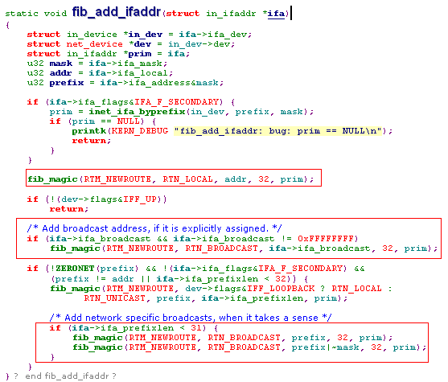
当End System发送Packet的目的地址为10.111.3.89时，它会首先查找main表，先从fz_order为32的开始查找，将目的地址与fz_mask做&运算，得出key值后，依据key值找到fz_node。这里会在fz_order为21的fz_zone中找到相应的fz_node，得到它的nh_gw, nh_oif和nh_dev。因为nh_gw值为0，因此将rt_gateway设置为10.111.3.89。于是将该packet从nh_dev对应的适配器中将该packet发送出去。
注：根据rt_gateway来生成目的Mac地址的。
当在End System中发送一个Packet到新浪的服务器：202.108.33.73， 从fz_order为32开始查找，一直到fz_order为1都没有找到相应的fz_node; 这时调用fib_select_default()在fz_order为0的fz_zone中查找，选择一条default route（默认网关），这时得到nh_gw, nh_oif和nh_dev， 这时得到的nh_gw为10.111.0.1，这时就根据nh_gw，将rt_gateway设置为10.111.0.1.于是将该packet从nh_dev对应的适配器中将该packet发送出去。
注：根据rt_gateway来生成目的Mac地址的。

